**Highschool Student From Dubai launches Android app**

A 16-year-old student from Dubai launches his first Android APP, by the name “Ultimate Highschool GPA calculator,” in hopes to make students’ lives easier when it comes to managing, assessing, and planning their grades throughout the school in one easy to use application. One can find his app on play store by accessing this [link](https://play.google.com/store/apps/details?id=com.devul.UltimateHSGPACalc).

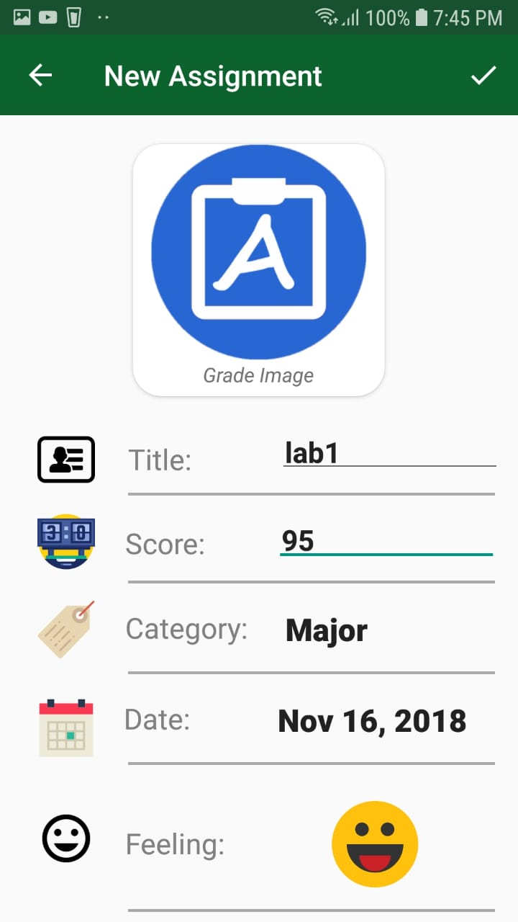Devul’s inspiration for this app stems from his everyday frustration that he faced when he was trying to assess how he was doing in grade 10 academically. Though he knew how to calculate a weighted GPA, he found it quite time-consuming to do so on a regular basis. After discussing this problem with his friends, it became apparent to him that he was not the only one facing this issue. Infact, according to Google trends about 600,000 people search for gpa calculators online every month in order to be able to manage their grades, but still a majority of them remain unsatisfied, as there is not a single system which provides them with detailed analysis on how they are performing academically. Most students ultimately end up wating for their end of the year report cards, and this often leads to uninvited surprises and develops more stress for students. This app sets to change that by giving the power of managing the student’s grades to the students.

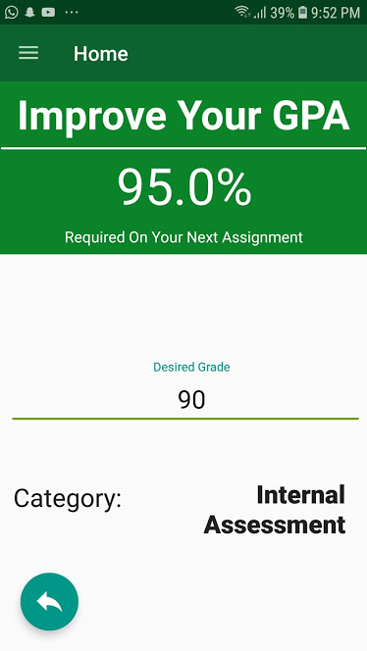All the student has to do now is enter the grades that they get for each assignment along with categorizing the assignment for a particular subject. These categories are predefined for every subject, but its percentage weightage can be changed according to the user’s requirements. Once the user has done this, the app use highly tested and advanced algorthims in order to build the student’s profile. This profile provides information such as the student’s subject, semester, year, and highschool gpa, percent average, and letter grade, along with providing them with additional features such as the student’s attitude towards their academic performance, a timeline of all of their assignments, and various pie, bar, and line graphs to allow the student full control of their grades. However, we have not even discussed the most exciting feature of this app. This app also gives students the ability to plan and predict grades that are required to maintain their gpa or to boost it to a desired gpa. This feature is specifically what makes this app stand out from other GPA calculators online and on the playstore.

Devul believes the reason this app could be expedient for students, is because it was developed by a student who was going through the same struggles the users of this app go through, and for this reason understands exactly how to tackle the issue. He hopes this app is just as beneficial to other students struggling to calculate their GPAs as it has been for him and his peers.

Combined with his deep love for technology, Devul is planning to enroll in his dream school, Stanford University, and hopes to continue providing solutions to people facing problems on an everyday basis.

APP Developer, Devul Nahar